|  |  |
| --- | --- |
| **Course signature** | TesterRemoteCZ9 |
| **Team members names and surnames** |  |
| **Project title** | Final Project |
| **Link to repository** |  |
| **Project description** (with listed, used technologies, testing plan) | For the final project we tested the website of online shop  <https://petstore.octoperf.com/actions/Catalog.action>  We were divided into 2 teams and,  for 20-30 minutes, we explored the website.  The first task was to prepare test scenario describing as many test cases as possible.  We created Test Cases which were classified in columns in Excel sheet.  We executed the test cases and we set up the status per step (passed/failed).  The bugs encountered were linked to the test cases and we established the severity for each one in TestRail.  We established the testing environment: Chrome, Safari, Firefox.  Were added outcomes: test executions, screenshots and comments.  To conclude the project we created a report (based on Test Metrics) which describes the entire project.  You will find bellow the conclusion report. |

**Final Project**

1. **General info:**

**Name project: Final Project**

**Version: Version 1**

**Epic: Group 2**

**Environment: 105.0.5195.127 on Windows 10**

**Cycle Summary: Group 2,** **https://petstore.octoperf.com/actions/Catalog.action**

**Excel Sheet with columns based on Stories:**

* **Registration of new user**
* **Sign In Page**
* **Prodcut offer menu**
* **Shopping**
* **History of orders**

1. **Test Metrics for Final Project**

**Group 2 executed 120 test cases in the period 14.9. - 16.9.2020; 111 passed, 1 blocked, 41 failed.**

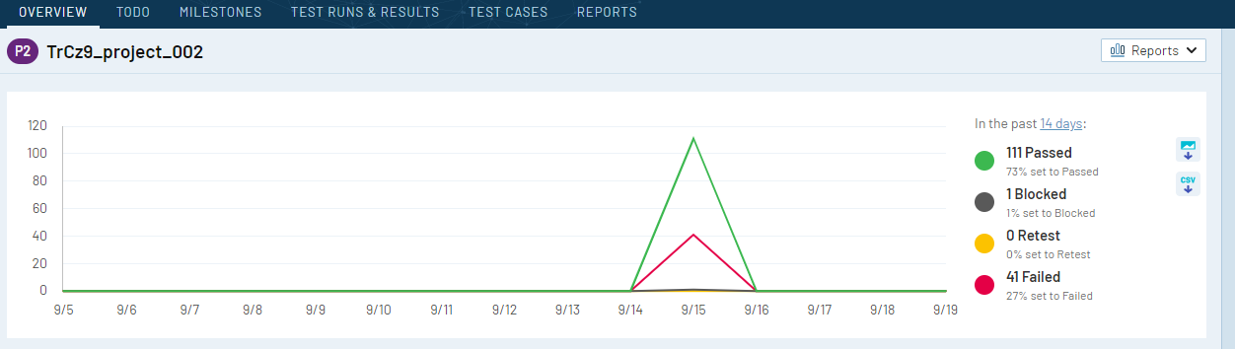

**Each member of our group 2 have created own Test Run where each member executed assigned test cases.**

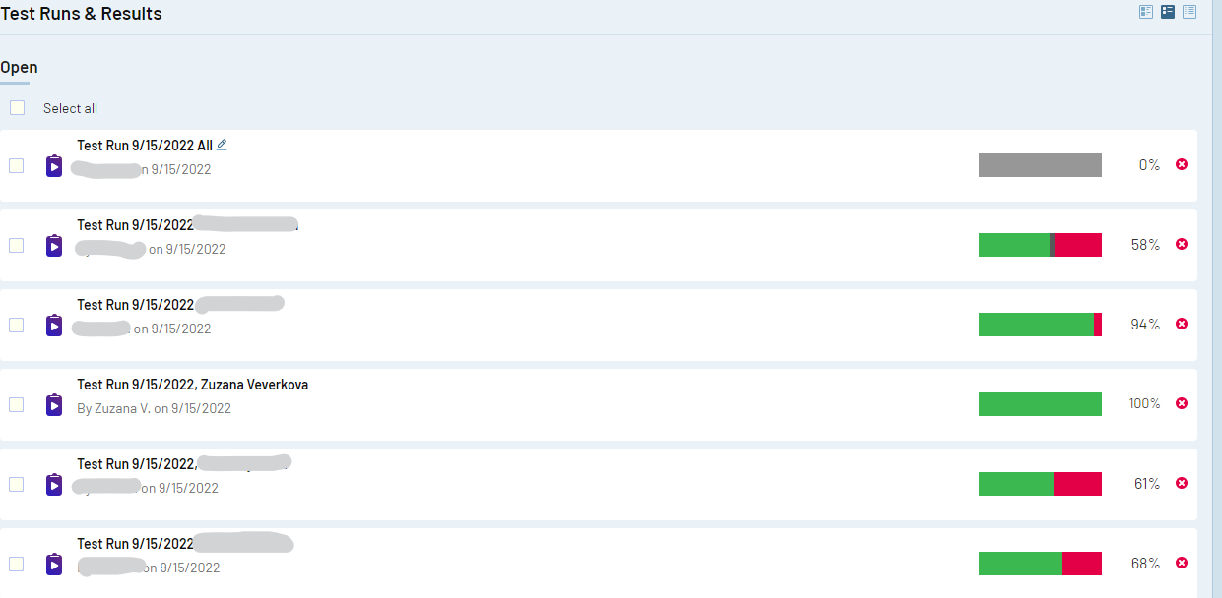

**Myself I had executed 14 test cases, 100% set to passed.**

